**Naari Shakti AI-Empowering Women**

**through Technology**

**INITIAL PROTOTYPE**

**FRONT END:**

Naari Shakti AI Chatbot uses real-time speech recognition and NLP (Spacy, Transformers) to detect distress in the user's voice as per Fig. 1. If distress is detected, it instantly activates emergency mode and starts video recording for evidence and send the live GPS location to emergency contact and authorities.

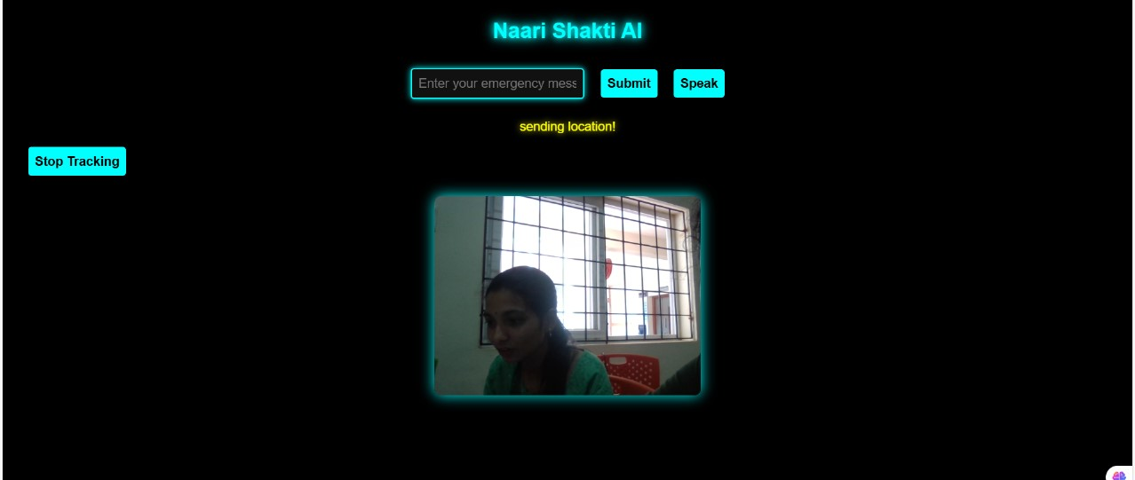

Fig. 1

Legal Help Webpage: Provides access to legal assistance, rights, and guidance shown in Fig. 2

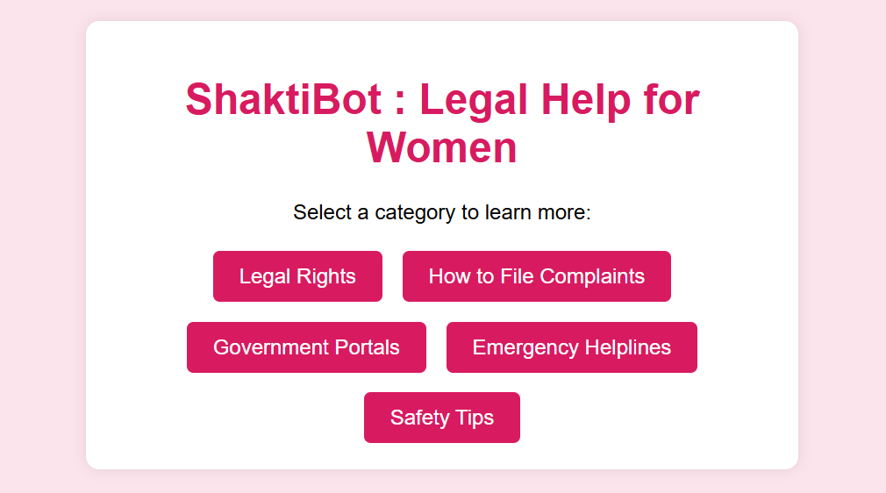

Fig. 2

**DATABASE:**MONGODB which stores the live GPS location of the user shown in Fig. 3

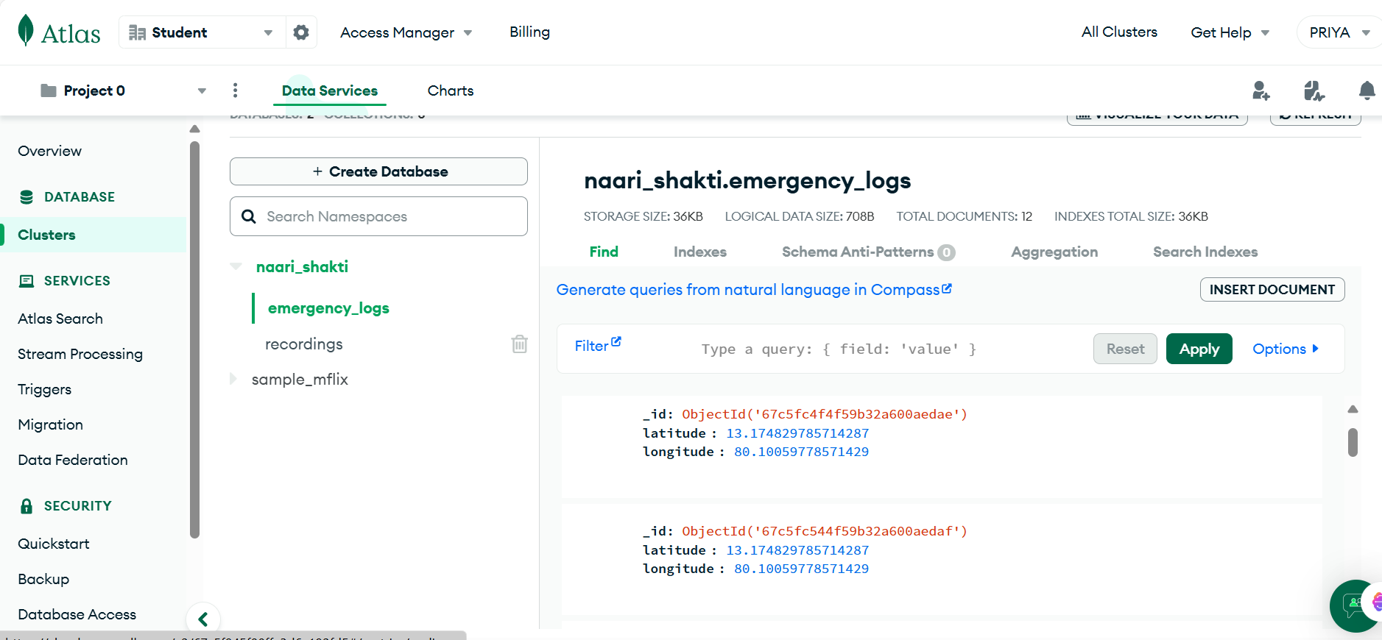

Fig. 3

It manages the user’s details, along with video file path and timestamp as per Fig. 4

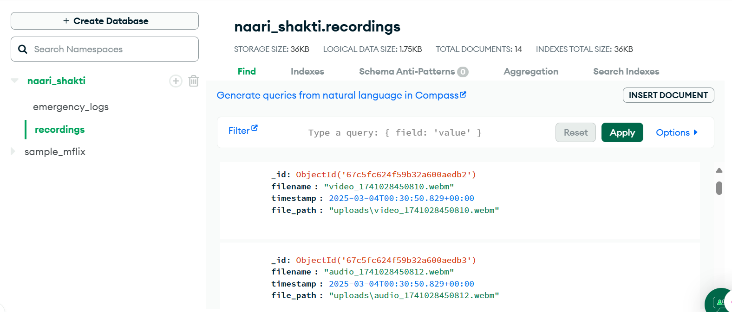

Fig. 4

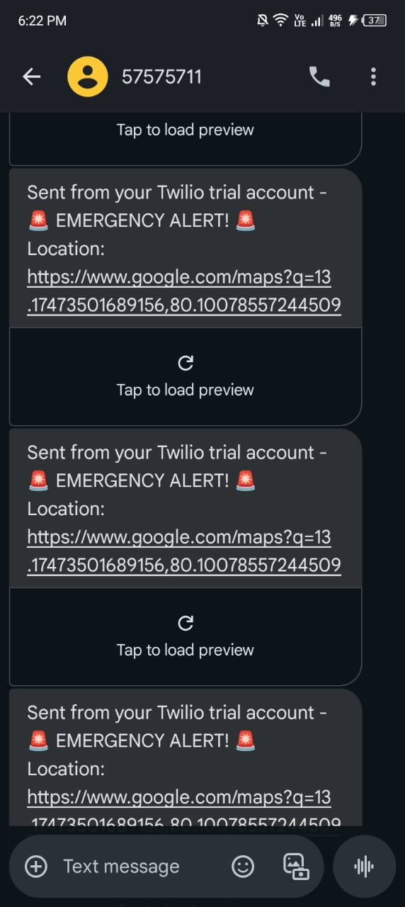

Fig. 5

The above Fig. 5 shows the real time implementation of Live GPS location message obtained by the emergency contacts of the user.

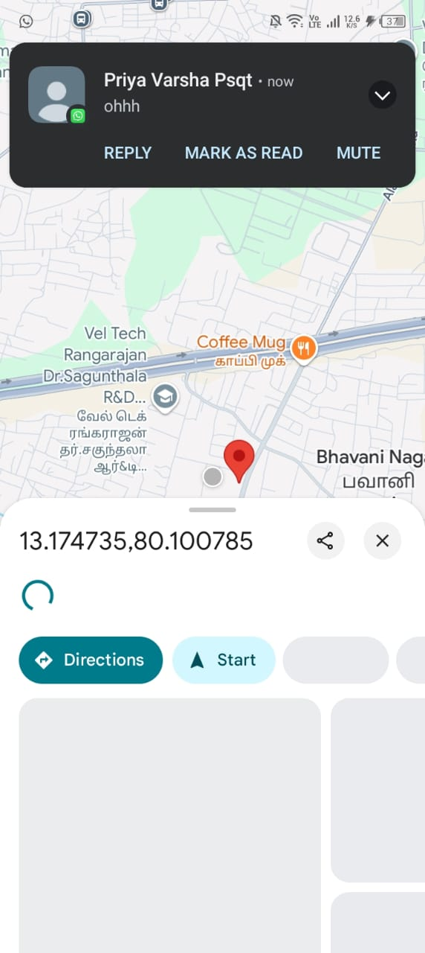

Fig. 6

The Fig. 6, depicts the GPS Map for tracing the user.

The further implementation of features such as Bluetooth in low connectivity, Firebase, integration of all components, etc. are in progress and we will be completed after receiving the necessary funding for the implementing these features.